Tutorial 9 Answers

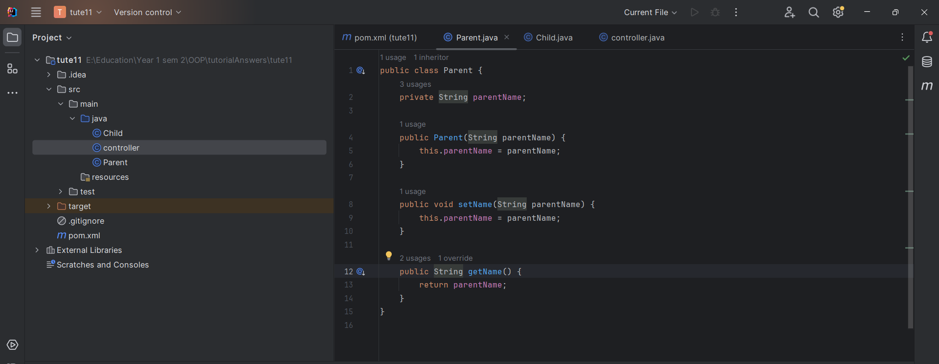

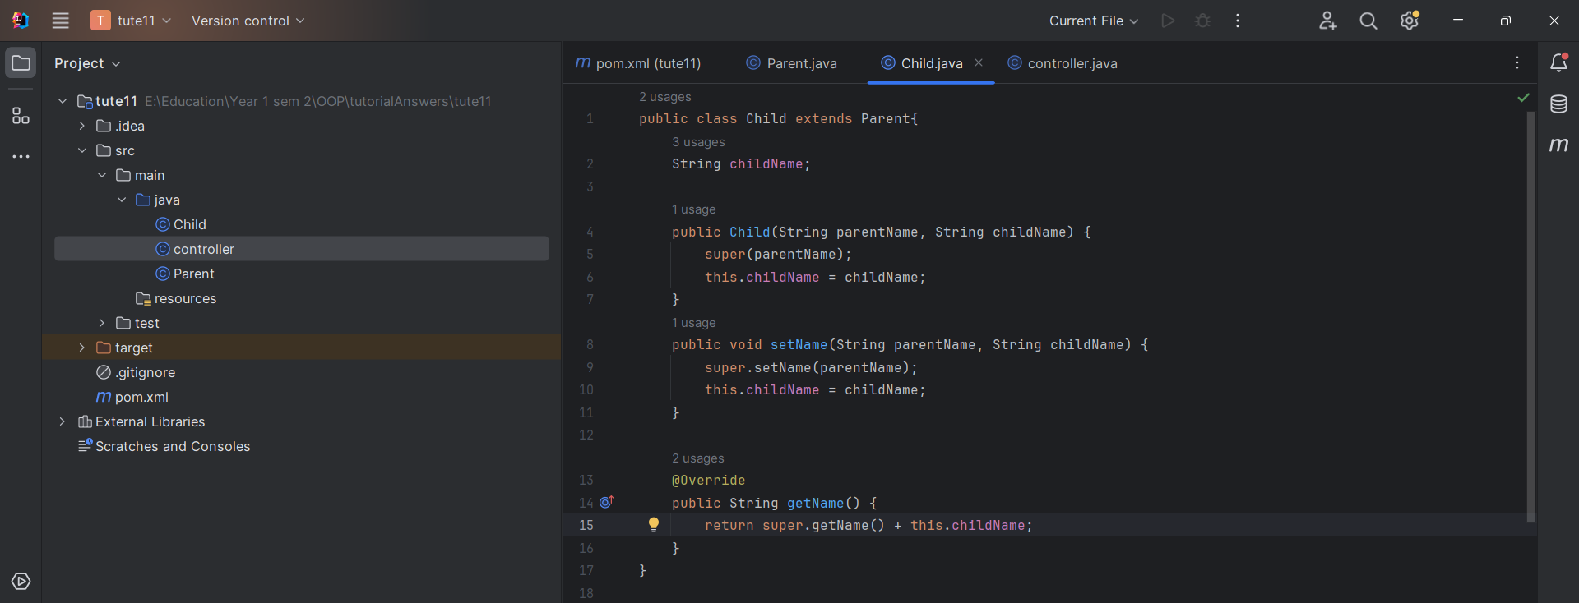

3)
4) Abstract class is classes that cannot be instantiated.
5) No
6) Can be implemented within a subclass.
7)

